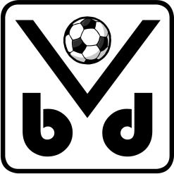 | REGISTRATION FORM  INTERNATIONAL YOUTH TOURNAMENT 2016  VERBROEDERING BEERSEL DROGENBOS  Saturday 14 May 2016: U13 Sunday 15 May 2016: U15

The undersigned ……….……………………………….……………………………………………………………………………………

of football club ………………………………………………………………….…….………………………………………………………

with team colours …….……………….……………………….. (shirt) and ……....………………………………..… (short)

wants to participate in the International Youth Tournament „Mayor Jean Calmeyn“, organised by Verbroedering Beersel Drogenbos, with the following team(s):

Category U 13 (born in 2003)
Category U 15 (born in 2001)

Contact person:

Name ……………………………………………………………………………………………………………….……………………………….

Street number and name .…………………………………………………………………………………………………………………

Postcode ..…...……………….. Municipality or city ……………………………………………………………………………….

Tel: …..…………………………………………….... E-Mail: ………………………………………..……………………………………….

Signature of club responsible (+ name if different from above) | Official club stamp

Please send this completed form to the following address by December 15th 2015:

Johan Rosiers, Jozef Springaelstraat 16, 1651 Lot-Beersel, Belgium.
Tel.: +32 498 13 75 04 E-mail: johan.rosiers@telenet.be

